SCENARIO NOTE: 12-16-2025

REF: Player Comments/Recommendations

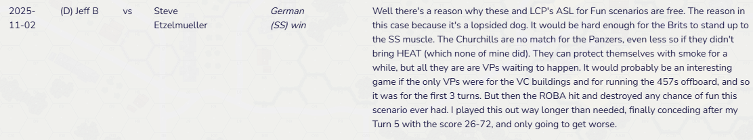
Recent comments indicated that the scenario was barking more than it should. Player made recommendations regarding the Victory Conditions. I have updated the scenario with these recommendations in mind and made other changes that should pull some of the teeth from a very strong SS force.
- Victory Conditions updated to remove “earning CVP normally”. With the strong SS force and the Rocket OBA, the British will always be hard pressed to earn CVP against the stronger German infantry and armor. Therefore, the British earn EVP for the 4-5-7’s exited off the board and both sides will continue to receive 2 VP for each stone building controlled in the designated victory area.
- German force has also been pared down to a single Tiger I, 2 x MKIV’s, 9 x 6-5-8’s instead of 10 and 3 x LMG’s instead of 4 and 1 Panzerschreck instead of 2.
- Lastly, the Rocket OBA will be available only after Turn 3 instead of Turn 2.

These changes should help the British cause and not undue the historical narrative presented. The later entrance of the Rocket OBA will more faithfully replicate it’s use to stop the relief force as opposed to the retreating 4-5-7’s. The later entry should allow the 4-5-7’s to get away from danger as they fall back.
Appreciate the comments!! And thanks for playing the scenario.

